P R E S S R E L E A S E

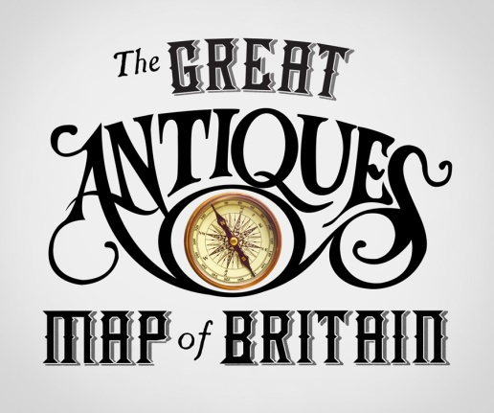

The Great Antiques Map of Britain is a new BBC series that is coming to your area. And they are looking for people to take part! Do you have an item from the local area with an interesting story; do you ever wonder if it might be worth something?

Tim Wonnacott embarks on a nationwide journey to discover the people, the places, the antiquities and the collectables that tell the story of Great Britain.

Britain is famed around the world for the quantity and quality and variety of its arts, crafts, collectables and antiquities. In this series, Tim Wonnacott sets out in his ‘Valuation Station’– an Airstream doubling as an antiques valuation centre - to visit the hotspots of British arts and antiques, from large festivals to local markets.
In each episode Tim rolls up into a specific city, town or village: each with a rich heritage in antiquities. From Glasgow with its Clutha Glass, to Bristol Fry’s Chocolate and Worcester’s Royal Porcelain. Each location provides a wealth of historical take out as Tim visits key sites and locations.
But while he’s there he’s also got some extra work to do. Pitching up his Valuation Station, Tim will throw down the challenge to the locals to bring him their precious family heirlooms and antiques for an expert opinion and appraisal. It’s their chance to show and tell. Will it be "Trash or Treasure Time"? Will any of the items have a life-changing value for the owners? And will Tim find any fabulous survivors of the region’s antique heritage amongst the offerings?

These journeys he will take us through the process of the creation of the artworks and antiquities revealing the fascinating human, industrial and social history of Britain.
An amusing and revealing gallivant around Britain’s antiques and art hotspots, “The Great Antiques Map of Britain " tells the history of the United Kingdom, through its renowned artistic heritage and the people and places who gave birth to it.
To contact the research team on The Great Antiques Map of Britain call: 0117 9742369 or email Great.Antiquesmap@bbc.co.uk

